**SUCCESS AND FAILURE RATE AT UNIVERSITIES USING DATA MINING**

AKSHAT KHAPRA  
[VIT CHENNAI,TAMIL NADU]

Akshatkhapra.44@gmail.com]

***Abstract-***

The paper describes the success and failure rate of universities using data mining technique to predict the number success and Failure rate at universities. Moreover the paper describes how various attribute affects the success and failure rate. The aim of the project is to develop a model which will fulfil the early prediction using data mining algorithum which peturb the future decision. As well as the project focuses on collection large number of attributes prognosis the future decision and will stands as a foundation of decision support for the future forecast. The above proposal uses the decision tree and naïve baye’s algorithum.

Keyword- SUCCESS AND FAILURE

1. **INTODUCTION**

As every country is depend upon the youth which play a major part in culminating the country. So a major steps which help the knowledge institution to decide about the several issues for youngsters. This research describes the key aspects of achievements and disappointment rate at universities. Also we have studied about numerous factors that influence the success and failure rate at universities. Moreover in survey various data mining technique is used. In which some has used the clustering technique, regression, SVM algorithum and decision tree to predict the achievement and disappointment rate with different data sets. The paper is done

Prof. PREMALATHA M.

[VIT CHENNAI, TAMIL NADU]

with prescience for future. As well as it plays major role for the education institution which has inexorable experience in disappointment rate. The paper has used the student data set from the primary to college level and used twenty four attribute for forecasting the disappointment rate. Furthermore we have used the decision and naïve baye’s algorithum with large number of data sets for divination.

**(2) LITERATURE SURVEY**

**Determining Students’ Academic Failure Profile Founded on Data Mining Methods**

The paper describes the universities achievement and disappointment rate by Using artificial neural network algorithum. In research a sample of a particular university is taken and its attribute is taken to foresight the disappointment rate. Moreover the paper has used a less number of attributes for prediction with the diagrametic model using histogram, bar-graph and pie-carts. As well as paper main focuses on the first and last year students for the early prediction of disappointment rate moreover the paper describes about universities proceeding on a extant course. As a result helps in role model for early forecasting .

**A Cross-Age Peer Tutoring Program to Prevent Academic Failure and Drop-Out among First Year University Students**

The youngsters are the culminated power of

the country. The paper fed a large number of debates among various universities for the failure rate also it describes that many statisticians have tried to forecast. Undermining, forecasting and preventing needs a continuous process as collected from student surveys. The article main focuses and experiments in the educational area using clustering method of data mining.

**Predicting college Failure and Dropout by Using Data Mining Techniques**

The paper focuses on the data mining technique to predict the success and failure rate. The data set used in this paper is from the senior secondary to all levels and used many attributes to forecast better the data used is from Zacatecas, Mexico around 670 colleges and used decision tree algorithum to improve the accuracy for future, furthermore in the paper data is rebalanced for cost effective classification and at the last various model is compared and the best model is chosen.

**METHODOLOGY**

**(DECISION TREE)**

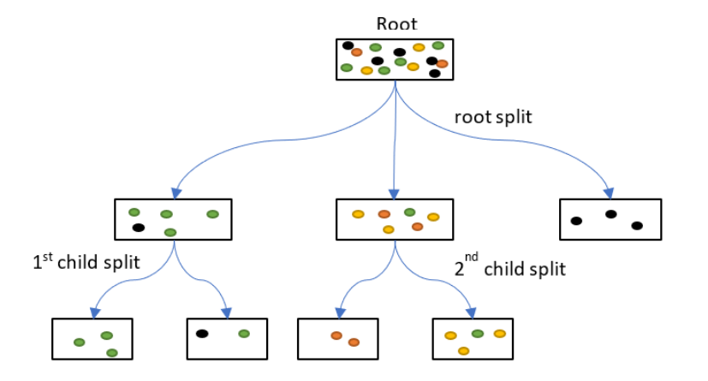

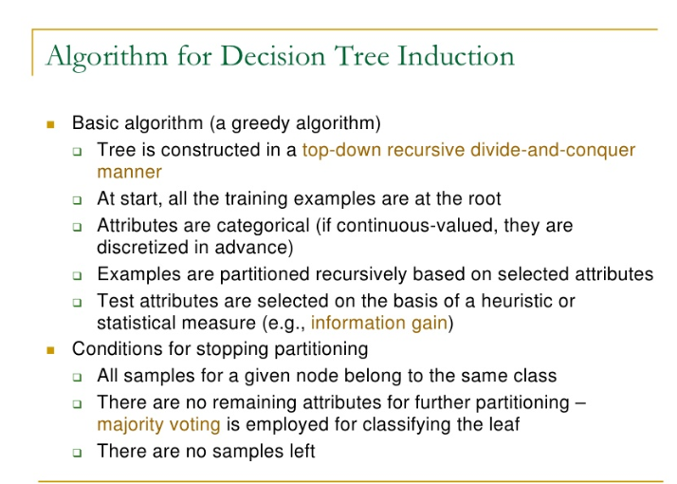

The paper uses the twenty four attributes with and uses decision tree algoritum to forecast the future disappointment rate. Moreover the dataset has converted into training and testing part. The dataset has more number of attributes and is different from all other p

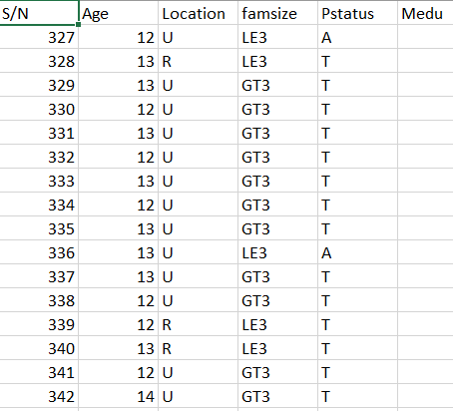

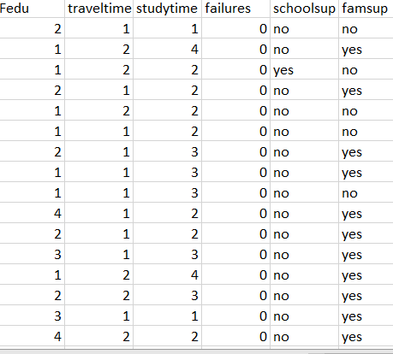

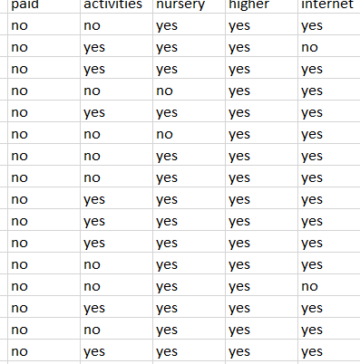

After selecting the dataset the data is converted by the code in the numeric form so that the prediction is done in the accurate form the technique is done with the python programming for better forecasting and the result is 81.340% accuracy.

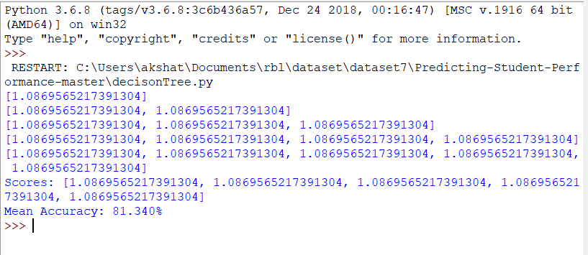

While the same dataset is used with the **naïve** **baye’s** algorithum the accuracy is quite better further more the algorithum is quite good for predicting the results the naïve bayes has:

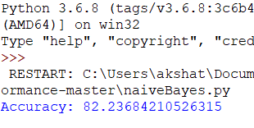

In naïve bayes algorithum each and evey column and row probability is counted for forecasting the future. The naïve bayes algorithum uses the concept of bayes mathemathical formula for probability counting.

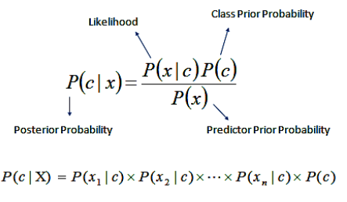

Comparing both the accuracy level the naïve baye’s has more accuracy than the decision tree algorithum.

**CONCLUSION**

The paper elaborates more on the early prediction as many papers has used certain algorithum with different attributes but the accuracy is done with the college academics reports. Afterall to predict more better the research is done with primary level to graduation and also the student personal attribute is taken to forecast better